Evaluation of Steelhead Kelt
Project Abundance, Condition, Passage, and Conversion Rates through Lower Columbia River dams, 2001

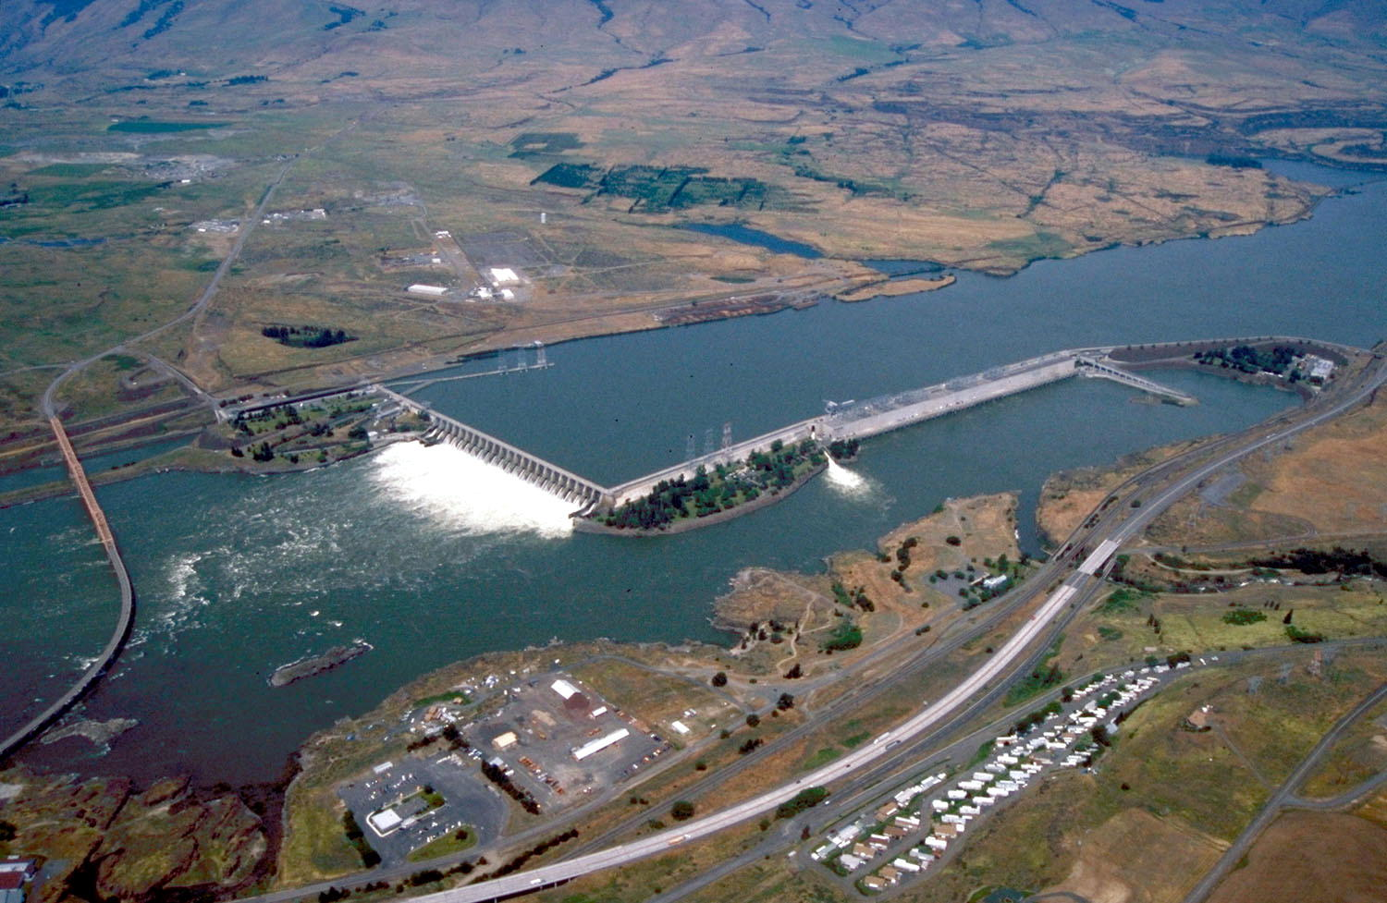

Report of Monitoring

Prepared By:
Robert H. Wertheimer, Patricia L. Madson, Mike R. Jonas, and John T. Dalen

U.S. Army Corps of Engineers
Portland District Fisheries Field Unit

Bonneville Lock and Dam
Cascade Locks, OR 97014

Prepared for:

U.S. Army Corps of Engineers
Portland District
Planning and Engineering Division
Environmental Resources Branch
Robert Duncan Plaza
333 S.W. 1st Avenue
Portland, Oregon 97204-3495

December 13, 2002

Executive Summary

We used ultrasound and radio telemetry to evaluate the project abundance, passage routes, and conversion rates (survival) of steelhead (Oncorhynchus mykiss) kelts (i.e., post-spawn fish that are potential repeat spawners) during their seaward migration through the Federal Columbia River Power System of the Columbia Basin. In addition, Passive Integrated Transponder (PIT) detection technologies were used to develop baseline information on the return rates of steelhead to the Columbia River. Currently, the project specific passage routes, passage rates, and returns of these fish, which may be important to stock recovery, are poorly understood.

In 2001, drought conditions persisted, causing limited periods of spill. Thus, we compare kelt travel routes and rates under spill and no-spill scenarios. We also examine the efficacy of an experimental bypass concept (occlusion) in guiding kelts into the ice and trash sluiceway (ITS) at The Dalles Dam. The objectives of this study were to determine kelt: 1) abundance and condition for McNary and John Day dams, 2) downstream travel times, 3) times and routes of dam passage, 4) project passage efficiencies and effectiveness 5) system conversion rates (through the I-205 bridge; ~5 mile east of Portland Or.), and 6) return rates of steelhead to the Columbia River.

General: Ultrasound images of steelhead visceral anatomies were used to differentiate pre-spawn fallbacks from kelts at McNary and John Day dams from April through June of 2001. Kelts at McNary, and John Day that were in good or fair condition were radio tagged (McNary n=53; John Day n=159), PIT tagged (McNary n = 68; John Day n = 495), and released back into bypass systems. In addition, data are reported from kelts radio-tagged (n=212) and released by Columbia River Inter-Tribal Fish Commission personnel at Lower Granite Dam (Evans 2002).

Abundance and Condition: At McNary Dam, estimates produced from ultrasound examinations indicate that 1,988 kelts were bypassed. Similarly, at John Day Dam, estimates based upon ultrasound examinations indicate that 2,022 kelts traveled through the bypass. At McNary and John Day dams, 67% and 72% of kelts sampled with ultrasound were categorized as being in good or fair condition, respectively.

Travel rates: Spilling water significantly increased the travel rates of kelts through the lower Columbia River. Similarly, spilling water significantly decreased forebay residence times at The Dalles and Bonneville dams. The travel rates of kelts contacted in the free flowing reach below Bonneville Dam were double those observed in the John Day pool.

The Dalles Dam: Telemetry data documents complete passage histories for 42% (88/212) of our kelts, and 9% (18/212) of the kelts released from Lower Granite. Most (68%; 71/104) of these kelts passed during periods of spill (30% project discharge). During spill, kelt passage efficiency (non-turbine / [non-turbine + turbine]) was 99%. Spill efficiency (SE) was 87% (spill / [non-turbine + turbine]), and spillway effectiveness (SF) was 2.9:1 (SE / [spill discharge / project discharge]). Kelt sluice passage efficiency was 69% (ITS / [ITS + turbine]). Sluiceway passage was almost equal during occluded (55%; 12/22) and un-occluded periods (45%; 10/22). All (n=12) kelts that traveled turbine units passed through under occluded conditions.

Bonneville Dam: Complete passage histories were produced by 63% (133/212) of our radio-tagged kelts, and 4% (9/212) of the kelts released from Lower Granite Dam. At Powerhouse I, kelt sluice passage efficiency was 89%. At Powerhouse II, kelt guidance efficiency was 52% (guided / [guided + turbine]). During 37% spill at Bonneville Dam, kelt passage efficiency was 84%. Overall, kelt passage efficiency was 68%.

Conversion rates: Of the 53 kelts radio tagged and released from McNary, 57% (30/53) were contacted by the sets of telemetry ‘survival gates’, which spanned the Columbia River channel near Reed Island, Lady Island, and the I-205 bridge. Similarly, of the 159 kelts released at John Day Dam 65% (104/159) were detected by these gates. Only 3% (7/212) of kelts released at Lower Granite Dam were contacted by these gates.

Preliminary return rates: As of September 2002, adult PIT-detectors at Bonneville, McNary and Lower Granite dams have documented returns by ~ 7.6% (43/563) of our PIT-tagged kelts. Return rates of kelts PIT tagged at McNary are currently at 10.3% (7/68), while rates from kelts released at John Day are at 7.2% (36/495).

Summary: Data from 2001 indicates that kelts can be effectively routed past dams using sluiceways and spill. Kelt sluice passage efficiencies of 69%, and 89% were documented at The Dalles, and Bonneville dams, respectively. No benefits were observed from occlusion (blocked trash racks) at The Dalles Dam. In fact, kelt turbine passage during occluded conditions warns of an ineffectiveness of this configuration for guiding kelts into The Dalles sluiceway. As in 2000 (Wertheimer et al. 2001), intake screen systems displayed poor efficacy in guiding kelts away from turbine units. Spilling water significantly reduced the travel and passage times of kelts through the projects and pools in the lower Columbia River. Moreover, during 30% spill at The Dalles Dam optimal (99%) kelt passage efficiencies were observed. Adult PIT detection systems proved effective at monitoring steelhead returns as indicated by the percentage of steelhead
(~ 8%) contacted on upstream migrations.

Table of Contents

EXECUTIVE SUMMARY…………………………………………………. i
Table of Contents.………………………………………………….. iii
LIST OF TABLES AND FIGURES…………………………………….…. v
LIST OF APPENDICES…………………………………………………… vii

Introduction…………………………………………………………. 1

Methods…………………………………………………………………. 2
Study Sites………………………………………………………….. 2
Kelt Sampling………………………………………………………. 3
Radio & PIT Tags…………………………………………………. 4
Fixed Receiving System (Telemetry-Equipment)……….………… 4
Data Management and Analysis……………………………………. 5

Results
Project Operations………………………………………………….. 6
McNary Abundance and Condition………………………………. 7
John Day Abundance and Condition...…………………………..… 8
Telemetry…………………………………………………………… 9
Travel Rates………………………………………………………… 9
Passage.……………………………………………………………. 10
John Day Dam ……………………………………………… 10
The Dalles Dam …………………………………………… 10
Bonneville Dam…………...……………………………….. 12
Conversion Rates…………………………………………………… 14
Radio-tag retention………………………………………………… 15
Return Rates………………………………………………………… 16

Project Summary & Discussion………………………………… 17

Acknowledgements………………………………………………... 18

References…………………..………………………………………… 19

APPENDICES…………………………………………………………….... 20

LIST OF TABLES AND FIGURES

TABLES

Table 1. Average flows through the Columbia River from 1 April to 30 June
at John Day, The Dalles, and Bonneville hydroelectric projects, 2001. 7

Table 2. Percentage of steelhead sample (n = 383) with head burn or head
fungus at McNary Dam in 2001. 8

Table 3. Condition and coloration of pre and post spawn steelhead sampled
at the McNary juvenile fish facility in 2001. 8

Table 4. Condition and coloration of pre and post spawn steelhead sampled

at the John Day smolt monitoring facility in 2001. 9

Table 5. Percentage of steelhead sample (n = 1,198) with head burn or head
fungus at John Day Smolt monitoring facility in 2001. 9

Table 6. Proportion of steelhead kelts radio-tagged in good, fair, or poor
condition at John Day and McNary dams. 9

Table 7. Travel times (hh:mm) of the three kelt groups through the pools
between the lower Columbia River dams to the survival
gates at I-205 bridge. 10

FIGURES

Figure 1. Passage histories at The Dalles Dam for the radio-tagged groups
from Lower Granite, McNary and John Day dams. 11

Figure 2. Passage history at Bonneville Dam for the radio-tagged groups
from Lower Granite, McNary and John Day dams. 12

Figure 3. Number of radio-tagged kelts entering each forebay at Bonneville
Dam during the weeks of no spill and the number that
passed a different forebay than the one they entered. Shown
are flow ranges for each forebay 1April through 15 May. 13

Figure 4. Number of radio-tagged kelts entering each forebay at Bonneville
Dam during the weeks of spill and the number that passed a diff-
erent forebay than the one they entered. Shown are flow ranges for
each forebay, 16 May through 16 June. 14

Figure 5. Contact and recapture percentage for the radio-tagged groups
from Lower Granite, McNary, and John Day dams. 15

LIST OF APPENDICES

Appendix A – Tables and Figures

Table A-1. Summary of the sample date, sample size (n), mean, standard deviation (SD) and range of the fork length (cm), sex, origin and ultrasound diagnostic of steelhead from McNary Dam in spring of 2001.

Table A-2. Summary of the sample date, sample size (n), mean, standard deviation (SD) and range of the fork length (cm), sex, origin and ultrasound diagnostic of steelhead from John Day Dam in spring of 2001.

Figure A-1. Weekly proportion of the total steelhead population sampled at
the smolt monitoring facility at John Day Dam, Columbia River 2001.

Figure A-2. Weekly proportion of the total steelhead population sampled at
the juvenile fish facility separator of McNary Dam, Columbia River 2001.

Appendix B – Kelt Telemetry Populace and Receiver Sites
Table B-1. Summary of the collection location and date, sample size (n), mean,
standard deviation (SD) and range of the fork length (cm), sex, and origin of
radio-tagged steelhead kelts in 2001.

Fixed receiver/antenna stations installed and maintained by University
of Idaho made available to Fisheries Field Unit and CRITFC.

USGS Telemetry Site Maps for 2002 for The Dalles and Bonneville Dams.

Appendix C – Morphology Key

Morphological Data Key – criteria used to categorize fish by condition, abdominal appearance and coloration.

Appendix D - Tag Retention Test

Tag Retention Test Results – the number of days tags were retained on kelts
held in fresh water tanks at the Bonneville SMF lab.

Appendix E – Test Schedule 2001

Schedule of occlusion plate status at The Dalles Dam from 1 April to 30 June.

Introduction

During their seaward migration from freshwater spawning habitats back to the Pacific Ocean, steelhead kelts are exposed to a variety of factors that affect their reproductive potential. In the Federal Columbia River Power System (FCRPS) of the Snake and Columbia rivers, the system-wide changes that are resultant from impoundment are recognized to negatively affect iteroparity rates (NWPPC 1986, ISG 1996). Despite this, the effects of hydroelectric projects on the survival and reproductive productivity of post-spawn Columbia Basin steelhead populations are poorly understood. This and a companion study (Evans 2002) were conducted to further our knowledge on the run timing, project abundance, condition, passage routes, and passage rates, from steelhead kelts during their seaward migration through the FCRPS of the Columbia Basin.

Limited information exists on the return rates of kelts passing through the FCRPS. Concomitantly, data are lacking on the effects on kelts of spill and mechanical structures (screen systems, sluiceways, surface bypass systems) employed to enhance the passage and survival of juvenile migrants. The efficiencies of spillways and mechanical structures, which are operated for guiding juvenile salmonids away from turbine units, vary by project, species, life stage, seasonal timing, river flow, and diel period (Whitney et al. 1997, NMFS 2000, Giorgi et al. 2002). Presently, it is believed that The Dalles Dam (TDA) spillway may not be a benign passage route during some spill conditions (Beeman et al. 2000). Thus, the National Marine Fisheries Service (NMFS) has requested that spill volumes be limited to 64% of the total discharge pending further review of passage survival and spill efficiency and effectiveness. Studies at TDA have indicated that 30% spill may be just as effective at passing juvenile salmonids as spill levels near 60% of the total discharge (NMFS 1998). The effects of spill levels on kelt passage and survival at The Dalles Dam and in the FCRPS are unclear.

To address the need for such data, we used radio telemetry to determine passage rates and passage routes of steelhead kelts migrating through lower Columbia River dams. We also examine the feasibility of using adult PIT detection technologies to document steelhead returns. A better understanding of steelhead kelt abundance, passage, and survival through the FCRPS will enable managers to develop strategies and adapt collector and bypass systems to better complement the reproductive potential of this species. In this report, data are presented from radio-tagged and PIT-tagged steelhead kelts released at McNary and John Day dams. Also included are data from kelts radio-tagged and released by Columbia River Inter-tribal Fish Commission (CRITFC) personnel at Lower Granite Dam (Evans 2002).

The objectives of this study were to determine kelt: 1) abundance and condition for McNary and John Day dams, 2) downstream travel times, 3) times and routes of dam passage, 4) project passage efficiencies and effectiveness 5) system conversion rates (through the I-205 Bridge; ~5 mile east of Portland Or.), and 6) return rates of steelhead to the Columbia River.

Methods

Study Sites-
The focus of this report is kelt project abundance, passage, and conversion through the FCRPS mainstem Columbia River dams described below.

McNary Dam, located at river mile 292, is the last fish collection and transport facility on the Columbia River. The navigation lock is located on the Washington shore with the spillway and powerhouse side by side perpendicular to river flow. McNary’s spillway consists of 22 vertical lift gates. The powerhouse contains 14 screened turbine units with a hydraulic capacity of 6,567 m³/s. There are two fish ladders at the dam for upstream passage, one located on each shore.

John Day Dam is located at river mile 215.6. The navigation lock is sited on the Washington shore with the spillway and powerhouse spanning the river to the Oregon shore. The spillway has 20 tainter gates. The powerhouse, with 16 turbine units and four skeleton bays, has a hydraulic capacity of 9,113 m³/s. The turbine units are fully screened (one 14” diameter orifice per gatewell) to divert downstream migrants into a collection channel and down to a smolt monitoring facility located on the Oregon shore. This facility has the capacity to divert juvenile and adult fish to tanks within the lab. There are two fish ladders at the dam, one on each shore. The John Day Pool (Lake Umatilla; 123 km) is approximately 76 miles.

The Dalles Dam is located at river mile 191.5. It is a distinct project as the powerhouse, which contains 22 turbine units and two fish units, and it’s concrete overflow wall is positioned parallel to the river flow along the Oregon shoreline. The hydraulic capacity of The Dalles is approximately 10,613 m³/s. The spillway connected to the overflow wall has 23 tainter gates and is perpendicular to the river flow. There are two fish ladders at the dam, one on each side of the river. There is no screening or bypass facility for downstream migrants at The Dalles. Sluice gates and gatewell orifices (one 6” diameter orifice per gatewell) allow fish to pass into the sluiceway and around the powerhouse to the tailrace. In 2001, blocking of the upper 45 feet of intake trash racks (occlusion) at the west end of the powerhouse was tested as a means of increasing sluiceway passage. Blocking the upper portions of trash racks increases the flow field intensity near the channel bottom while decreasing mid-depth flow field intensity (NMFS 2000). The Dalles pool (Lake Celilo; 35.9 km) is approximately 24 miles.

Bonneville Dam is located at river mile 145.5, and is unique among Columbia River Basin hydroelectric projects as it consists of two separate powerhouses and an unattached central spillway. Each powerhouse has it’s own adult fish ladder system and JBS. At the powerhouses fish entering into the turbine intakes can pass above screen systems (guided) into gatewells or sound down through turbine units. Fish that are guided into gatewells, could either pass through orificesinto the juvenile bypass system (JBS), or sound through turbine intakes. Powerhouse I (PH I) connects Oregon on the south shore and Bradford Island on the north and contains ten turbine units with a total hydraulic capacity of ~ 3,850 m³/s. The Bonneville Dam spillway, which lies between Bradford and Cascades Islands, has 18 spill gates that are raised vertically allowing water to flow under the gates and down an ogee spillway. Powerhouse II (PH II) is separated from the spillway on the south end by Cascades Island and connected to the Washington shore on the north end. It contains eight turbine units and two fish units with a total hydraulic capacity of about 4,332 m³/s. The Bonneville pool (Lake Bonneville; 74 km) is approximately 46 miles.

Kelt Sampling
Seaward migrating kelts were obtained from the U.S. Army Corps of Engineers
(COE) smolt monitoring facilities (SMF) at McNary (McN) and John Day (JDD) dams. Steelhead were removed from either the bypass separator at McN, or the adult holding tank at JDD, and transferred via sanctuary dip-net to a nearby sampling tank containing river water with a buffered solution of clove oil at 30 mg/L (Prince and Powell 2000). To differentiate between kelts and pre-spawn fallbacks, specimens were scanned with an Aloka® ultrasound machine to assess gonadal maturation and sex (Evans and Beaty 2000). Sexually mature steelhead were released back to the bypass system, while confirmed post-spawn fish were classified as kelts and retained. For the purpose of this validation, we assumed ultrasound correctly classified maturation with 100% accuracy. Previous work suggests ultrasound correctly classifies the maturation status of 98% of the male and 100% of the female steelhead (Evans and Beaty 2000). Kelts were scanned for the presence of radio and PIT tags prior to tagging. If a tag was detected, fish condition factors were enumerated, tag number and tag type denoted, and the kelt placed into the recovery area.

Fish condition factors were evaluated concurrent with the ultrasound spawning status identification (Evans and Beaty 2000). Data on fish length (fork length), condition (good, fair, poor, dead), coloration (bright, intermediate, dark), fin wear, fungus (ranked by degree of severity), hatchery or wild lineage (adipose fin clips), physical anomalies (e.g., head burn), and the abdominal appearance (fat, intermediate, imploded/thin) were recorded. Examination and tagging time averaged approximately five minutes per specimen.

At McNary Dam, SMF personnel document the origin (i.e., hatchery; naturally produced) based upon adipose fin clips, visually identify (i.e., kelt or prespawn), and rate the condition (good, fair, poor, dead) of all steelhead passing through the bypass. Sampling with ultrasound took place between 3 April and 1 June, occurring three days a week for approximately 7 to 10 h/day. To account for the passage of kelts during periods not sampled with ultrasound, data from each passage week (Sunday–Saturday) were expanded using weighted means (Zar 1996); the proportion of kelts identified by ultrasound during each sampling week was multiplied by the total number of steelhead removed from the separator. Thus, our abundance estimates were generated under the assumption that kelts passing through the bypass are reflective of the overall kelt populace passing McN. Due to logistical constraints, random and nighttime sampling did not occur. Because, prior work at Lower Granite (LGR) and Little Goose dams found no evidence to suggest the proportion of kelts to prespawners during the day differed from those at night (Evans and Beaty 2000), we assumed that proportion of kelts to prespawners during the day did not differ from those at night.

At John Day Dam, adult downstream migrants and pre-spawn salmonids that pass through the juvenile bypass system typically flow through bypass back to the river (un-sampled). Diverting adults (at the bypass switch-gate) into the adult holding tank began March 30 and continued through June 20 (typically 4 day/week-24 hour/day). During sampled periods (24 hour/day) all adult steelhead traveling through the bypass were routed to the adult holding tank for ultrasound examinations.

Radio & PIT Tags
Sixty-nine day radio-tags operating on a frequency of 150.600 MHZ were attached to steelhead kelts that were classified as being in good or fair condition. Kelt reconditioning work on the Yakima River has demonstrated low survival rates by kelts classified in poor condition (A. Evans et al. 2001). Radio tags were 10.3 mm (diameter) x 29 mm, weighed 3.7 g in air, and transmitted once every five seconds. Each radio-tag was wrapped with polyolefin securing a 0.05 cm. hollow tube underneath. A 16 cm piece of size 1 chromic-gut reabsorbing suture was inserted through the tubing of the transmitter; surgical needles were tied to each end of the suture. The tagger pushed the needles through the cartilage at the base of the kelts’ dorsal fin; insertion points were separated by three dorsal spines. Needles were then removed from the suture and a surgical knot snugly tied affixing the transmitter to the kelt. PIT tags (134.2 KHz) were inserted into the musculature ventral to the pelvic girdle. Sampled steelhead were allowed to exit recovery areas to the bypass of their own volition.

Fixed Receiving System Telemetry-Equipment
Transmissions from radio-tagged kelts were monitored by aerial and underwater antenna/receiver ‘fixed station’ arrays located in and around TDA, Bonneville (BON), mainstem tributary entrances, and through sets of survival gates culminating at the I-205 bridge. Fixed stations were installed and maintained by University of Idaho (UI; Appendix B) and by U.S. Geological Survey (USGS) researchers (USGS fixed array stations described by S. Evans (et al. 2001), and Beeman (et al. 2001). Underwater dipole and stripped co-axial antennas had a limited range (about 6 m) compared to aerial antennas (100 to 300 m depending on transmitter depth, receiver gain, and number of elements). When positioned directly below aerial antenna arrays, tagged kelts were detectable to 8 m in water depth (Kelly and Adams 1996). Underwater antennas were specifically used to detect tagged fish in and around submerged traveling screens (STS), extended submersible bar screens (ESBS), ice and trash sluiceways (ITS), and JBS.

The underwater antennas were monitored with Digital Spectrum Processors (DSP) or the Multi-Integrated-Telemetry-Array-System. These systems automatically identified the specific antenna and location where a radio-transmission was received. Aerial fixed receiving arrays consisted of up to eight antennas connected to a Lotek SRX 400 receiver. In contrast to the DSP or MITAS arrays, SRX 400 receivers combined signals from all attached antennas and recorded transmissions as a ‘master’ antenna contact. The receiver cycled through each antenna separately to determine the specific antenna where a radio-tag’s transmission was located. If several radio-tagged fish were present, it took approximately two minutes for the receivers to listen all antennas combined, listen to each antenna separately, and log transmissions for each frequency. This procedure was then repeated through all frequencies before completing a scan cycle (S. Evans et al. 2001). For this reason, criteria were developed to determine what constituted a valid kelt contact at a fixed station. In general, a telemetry contact was considered valid when two or more transmissions from a unique radio-tag were recorded at a fixed station in less than three minutes. The three-minute rule was adopted for two reasons. First, receivers occasionally picked up weak transmissions from tagged kelts outside the immediate area of the receiver’s antennas. Second, when several radio-tagged kelts were transmitting near a receiver bank, receivers could potentially mix the radio transmissions of two or more tags and incorrectly record this signal as a different radio-tag. If the three-minute rule failed to filter out the false presence of a radio-tagged kelt in an area due to weak or mixed radio signals, contacts were negated through proofing verification. Telemetry records were only accepted if the record of a kelt’s plausible passage history was supported by telemetry hits before and after each contact.

The short duration of the kelt passage season prompted kelt releases prior to underwater monitoring at TDA. Telemetry arrays were installed and maintained as part of other broader objectives, and were not available to monitor all components of the kelt run (e.g., early run). Survival gates were operational at the time of initial releases, thereby, addressing a primary study objective (system conversion). As previous work demonstrated that the passage behavior of kelts was not influenced by collection point or release location (Wertheimer et al. 2001), we assumed no differences between kelts released at JDD and kelts released at McN.

Data Management and Analysis
While evaluating kelt system conversion, we are unable to provide estimates of kelt survival. An assumption of most telemetry survival studies is that test fish are representative of the general (i.e., untagged) population (Burham et al. 1987). Toward this end, conservative radio-tag to body weight standards (i.e., tags < 2% of body weight) were maintained (Brown et al. 1999). However, this and other assumptions fundamental to current mark recapture telemetry survival models were not formally verified (e.g., capture and re-release do not affect survival rate). Returns to the Columbia River from previously tagged kelts, suggest that kelt behavior and survival were not overtly affected by the presence of a radio-tag. As kelts were individually processed, tagged, and released, our hypothesis tests are based on treating the individual fish as the basic unit, rather than treating groups of kelts released on the same day as a ‘cluster’ (Table B-1).

Downloaded data from fixed receiver arrays maintained by the USGS were transferred directly to us. After downloading, UI fixed telemetry array data were forwarded by UI personnel to the National Marine Fisheries Service North West Fisheries Science Center (NWFSC) for formatting and coding. Contact locations with our specific frequency and codes were then sent to us from the NWFSC. Residence, passage, and travel times (hh:mm) were calculated to describe the time it took for kelts to travel past the FCRPS projects through the final set of survival gates. As well, the cumulative number of directional changes (CNODC; determined by movements between telemetry arrays) was used as a measure of the amount of lateral movements exhibited by kelts in forebay areas. Due to multiple forebay areas at BON, full and final forebay residence times were calculated for each radio-tagged kelt contacted in any of the near-dam areas (ca. ~ 100 m). Full forebay residence times are between the first and last contacts in forebay areas. Final forebay residence times are the amount of time between the first and last contacts in the forebay from which a kelt passed BON. Due to receiver limitations, forebay residence times were a conservative estimate of the actual time that tagged-kelts spent in the near-dam area. For instance, kelts may have been in the near-dam area prior to their first radio-contact and following their last contact. Passage times are defined as the time it took from initial contact in forebay areas to the time at which kelts were contacted at tailrace exit stations. Travel times were calculated by identifying the amount of time, kelts took to pass from first tailrace contact to first contact at the exit station. Due to potential violations in assumptions of data normality, nonparametric tests were used to compare residence and passage times (Zar 1996). All analyses were conducted in Statistical Analysis Systems (SAS, version 8.0, SAS Institute Inc., Car N.C., USA).

To compare juvenile and kelt emigrational histories, metrics used to describe the efficacies of spill and mechanical structures in passing juveniles away from turbines were generated. These metrics include calculations of fish passage and guidance efficiencies, and system effectiveness. Fish passage efficiencies are the percentage of total fish approaching a project that are passed by routes other than turbines. Fish guidance efficiencies focus on the performance of mechanical structures (typically screens) in routing fish away from turbine intakes into juvenile bypass systems. To allow direct comparison to guidance estimates, sluice passage efficiencies focus on fish that pass around a powerhouse via sluice. The effectiveness of systems that rely on water (sluice, spill, surface bypass) to pass fish away from turbines are reported by the percentage of fish passed by that route, divided by the proportion of total project discharge through that route. Typically, a 1:1 relationship is assumed between the percent of total fish that pass through the spillway and the percentage of total-river flow passing through the spillway (Whitney et al. 1997). The employed metrics are defined below:

• Spillway efficiency (SE) = (spill / [non-turbine + turbine])
• Spillway effectiveness (SF) = (SE / [spill discharge / project discharge])
• Kelt passage efficiency (KPE) = (non-turbine / [non-turbine + turbine])
• Kelt sluice passage efficiency (KSLPE) = (sluice / [sluice + turbine])
• Kelt guidance efficiency (KGE) = (guided / [guided + turbine])

Results

Project Operations
The volume of water flowing through the Columbia River in April, May, and June of 2001 averaged 122.4, 125.4, 125.5, and 134.2 kcfs at McNary, John Day, The Dalles, and Bonneville dams, respectively. Spill occurred every other day at McNary Dam from 26 May through 15 June, at an average of 15 kcfs per day. Spill occurred every day at John Day Dam from 26 May through 15 June, at an average of 18.2 kcfs per day.

At The Dalles Dam, a ‘juvenile’ spill pattern occurred every day (24 hour/day) from 16 May to 15 June, at an average of 40.7 kcfs per day. The juvenile spill pattern emphasizes moving water through the northerly portion of the spillway in an attempt to pass juveniles away from shallow areas, rocks, and islands present in the south half of the tailrace. Such structures within tailrace areas provide refuge for opportunistic piscine predators, to prey upon juvenile salmonids disoriented from dam passage (Shively et al. 1996). Spill represented approximately 30% of total discharge through The Dalles Dam.

At Bonneville Dam, ‘adult attraction’ spill occurred during the study prior to 16 May. During this period, 1.2 kcfs of water passed through each of spillbays 1 and 18, representing, roughly 2% of total project discharge. As well, during three 5 h blocks on May 24-25, this spill pattern and 2% discharge were observed. From 16 May through 15 June approximately 50 kcfs per day were passed through 10 spillbays, typically representing about 37% of project discharge. Overall, at Bonneville Dam, allocation of mean daily river discharges was generally about 72% through ‘the priority’ powerhouse (PH II), 22% through the spillway, and the remaining 6% through PH I. Mean discharges through the dams, before, during, and after periods of spill can be seen below (Table 1).

Table 1 Average flows through the Columbia River from 1 April to 30 June at John Day, The Dalles, and Bonneville hydroelectric projects in 2001.
Project | Before Spill | During Spill | After Spill
John Day  The Dalles  Bonneville | 116.5 kcfs  117.4 kcfs  125.5 kcfs | 140.0 kcfs  138.6 kcfs  150.1 kcfs | 121.6 kcfs  122.8 kcfs  127.3 kcfs

McNary: Abundance and Condition
At McN, between 3 April and 2 June (period evaluated with ultrasound) SMF personnel bypassed (sorted back to the river) 2,390 steelhead of which 25% (606/2,390) were visually identified as pre-spawn and 75% (1,784/2,390) as kelts. Overall, ultrasound examinations were preformed on 16% (383/2,390) of bypassed adult steelhead (Appendix A-1) during the study. The ratio of kelts to pre-spawners changed throughout the study period with kelts encompassing almost 100% of the sample as the season progressed into June. This pattern of increased kelt abundance as the season progresses is substantiated by prior kelt work in the Columbia Basin (Evans and Beaty 2000). Three hundred twenty-eight of the specimens were classified with ultrasound as kelts and the remaining 55 individuals as pre-spawn steelhead. These examinations indicate (weighted means; by week) that 84% (1,988) of the steelhead passing the separator during this period (3 April through 2 June) were kelts. Roughly, 67% (220/327) of examined kelts were categorized as being in good or fair condition. Most sampled kelts (95%; 309/327) were rated as having bright or intermediate coloration (Table 3). The majority (92%; 173/189) of sampled kelts (where sex was discernible) were female. Condition factors of recaptured kelts (from LGR) were recorded and these kelts released without ultrasound examination.

Based on adipose fin clips, SMF personnel documented that 57% (1,183/2,065) of steelhead they identified as kelts were naturally produced. Similarly, 63% (205/328) of the steelhead determined to be kelts via ultrasound were naturally produced. The prevalence of head burn and other head conditions from sampled steelhead can be observed below (Table 2). Head burn affliction is defined by Elston (1996) as an “exfoliation of the skin and underlying connective tissue of the jaw and cranial region of salmonids”. Overall, condition characteristics from individual specimens sampled with ultrasound can be observed in Table 3.
Table 2. Percentage of the steelhead sample (n = 383) at McNary Dam with head conditions.
Condition | Pre-spawn |  | Kelt |  | Total
Head burn |  | 4 (1.0%) |  | 73 (19.1%) | 77 (20.1%)
Head fungus |  | 5 (1.3%) |  | 55 (14.4%) | 60 (15.7%)
Head burn & fungus |  | 1 (0.3%) |  | 37 (9.7%) | 38 (10.0%)
Head scrape |  | 0 |  | 4 (1.0%) | 4 (1.0%)
Total |  | 10 (2.6%) |  | 169 (44.2%) | 179 (46.8%)

Table 3. Condition and coloration of pre and post spawn steelhead, as well as steelhead with unidentified maturation, sampled at the McNary juvenile fish facility in 2001.
 | Pre -Spawn Coloration |  |  |  | Kelt Coloration
Condition | Bright | Intermediate | Dark | Total | Bright | Intermediate |  | Dark | Total
Good | 37 | 5 | 0 | 42 | 80 | 91 |  | 2 | 173
Fair | 1 | 3 | 0 | 4 | 11 | 36 |  | 0 | 47
Poor | 3 | 6 | 0 | 9 | 9 | 80 |  | 15 | 104
Dead | 0 | 0 | 0 | 0 | 1 | 1 |  | 1 | 3
Total | 41 | 14 | 0 | 55 | 101 | 208 | 18 |  | 327*
*Coloration of one additional kelt was not recorded

John Day: Abundance and Condition
At John Day Dam, steelhead were collected over a nine-week period (Appendix A-2). At JDD, we identified 1,105 of the estimated 2,022 kelts that passed through the facility. The majority of the sampled steelhead were identified as kelts (92%; 1,105/1,207). Roughly, 72% (794/1,105) of examined kelts were categorized as being in good or fair condition. Most kelts (95%; 1,043/1,103) were rated as having bright or intermediate coloration (Table 4). The prevalence of head burn and related conditions from the sampled steelhead populace are also depicted below (Table 5). The majority (92%; 619/671) of sampled kelts were female. Documented sexual ratios (from McN and JDD) reflect prior data from the Columbia Basin (Leider et al. 1986, Evans and Beaty 2001), and the sexual ratios of kelts from other anadromous iteroparous salmonids.

Table 4. Condition and coloration of pre, and post spawn steelhead, as well as steelhead with an unidentified maturation status, sampled at the John Day smolt monitoring facility in 2001.
 | Pre-Spawn Coloration |  |  |  | Kelt Coloration
Condition | Bright | Intermediate | Dark | Total | Bright | Intermediate | Dark | Total
Good | 36 | 20 | 1 | 57 | 320 | 212 | 0 | 532
Fair | 2 | 14 | 1 | 17 | 62 | 187 | 13 | 262
Poor | 0 | 21 | 5 | 26 | 42 | 198 | 45 | 285
Dead | 0 | 1 | 1 | 2 | 2 | 20 | 2 | 24
Total | 38 | 56 | 8 | 102 | 426 | 617 | 60 | 1103*
*Coloration was not recorded for two recaptured kelts
Table 5. Percentages of steelhead sample (n = 1198) with head burn or head fungus at the John Day Dam smolt monitoring facility in 2001.
Condition | Pre-spawn | Kelt | Total
Head burn | 17 (1.4%) | 184 (15.4%) | 201 (16.8%)
Head fungus | 7 (0.6%) | 26 (2.2%) | 33 (2.8%)
Head burn & fungus | 5 (0.4%) | 14 (1.2%) | 19 (1.6%)
Head scrape | 0 | 5 (0.4%) | 5 (0.4%)
Total | 29 (2.4%) | 229 (19.2%) | 258 (21.6%)

Telemetry
Releases of radio tagged kelts were conducted as proportionally as possible to the overall kelt run. Radio tags were attached to 212 kelts (McN n = 53; JDD n =159). Of the 212 radio tagged kelts six were in poor condition, 52 were in fair condition, and 154 of the kelts were in good condition (Table 6). A summary of the morpho-metric information from collected kelts can be observed in Appendix B.

Table 6. Proportion of steelhead kelts radio-tagged in good, fair, or poor condition at John Day and McNary dams.
Condition (n = 212) | John Day | McNary | Total
Good | 112 (52.8%) | 42 (19.8%) | 154 (72.6%)
Fair | 42 (19.8%) | 10(4.7%) | 52 (24.5%)
Poor | 5 (2.4%) | 1 (0.5%) | 6 (2.9%)
Total | 159 (75%) | 53 (25%) | 212 (100%)

Travel rates
Travel rate data are based upon the 212 released kelts; these data are influenced by the number of individual kelts from each release group (Appendix B) subsequently contacted by fixed telemetry sites. Kelts must have been contacted by arrays in the tailrace from the dam in which they passed, and contacted in the subsequent forebay for travel times to be calculated. Thus, travel times through the river-reaches are often based upon sample sizes smaller than the full number of kelts passing each dam. Travel times for the released groups of kelts, through the I-205 Bridge are depicted below (Table 7).

Table 7. Travel times (hh:mm) of the three kelt groups through the pools between the lower Columbia River dams to the survival gates at I-205 bridge.
Travel rates (hh:mm) | n | Mean | Median | Min | Max
Lower Granite Kelts
The Dalles Pool | 14 | 25:23 | 12:53 | 9:47 | 185:08
Bonneville Pool | 9 | 31:31 | 30:17 | 22:07 | 43:18
Passage time from 1/2BO  to I-205 | 7 | 13:28 | 13:36 | 12:18 | 14:58
McNary Kelts
John Day Pool | 7 | 310:00 | 263:39 | 144:04 | 578:25
The Dalles Pool | 17 | 14:10 | 12:52 | 6:35 | 36:55
Bonneville Pool | 26 | 30:09 | 28:41 | 21:12 | 45:24
Passage time from 1/2BO to I-205 | 29 | 15:20 | 13:48 | 10:22 | 37:18
John Day Kelts
The Dalles Pool | 38 | 25:33 | 22:07 | 12:00 | 75:08
Bonneville Pool | 78 | 38:39 | 36:43 | 7:37 | 123:26
Passage time from 1/2BO to I-205 | 64 | 16:51 | 15:34 | 10:56 | 37:11

Travel Rate (Spill vs. No Spill)
The travel rates of kelts through the The Dalles pool were significantly faster during spill conditions (n=34) than the travel rates of kelts before spill (n=30; 2.51 km/hour versus 1.84 km/hour means, 2.43 km/hour versus 1.73 km/hour medians; two sample t-test for means, groups with equal variances, DF = 62, P < 0.0036).

The travel rates of kelts through the Bonneville Pool were significantly faster during
spill conditions (n=46) than the travel rates of kelts before spill (n=59; 2.40 km/hour versus
2.05 km/hour means, 2.39 km/hour versus 1.92 km/hour medians; Wilcoxon two-sample test, normal approximation, two-sided, DF = 45, P < 0.0001).

The travel rates of kelts below Bonneville Dam to the I-205 bridge were significantly faster during spill conditions (n=58) than the travel rates of kelts before spill (n=42; 3.62 km/hour versus 3.02 km/hour means, 3.73 km/hour versus 3.12 km/hour medians; two sample t-test for means, groups with equal variances, DF = 98, P < 0.0001).

Passage – John Day Dam
Due to drought conditions in 2001, underwater monitoring at JDD was cancelled. As a result, little information on kelt passage distributions are available from this project.

Passage - The Dalles Dam
Telemetry data provided complete passage histories for 42% (88/212) of kelts released from McN and JDD at TDA. In addition, roughly 9% (18/212) of LGR released kelts had complete passage histories at TDA (Figure 1).
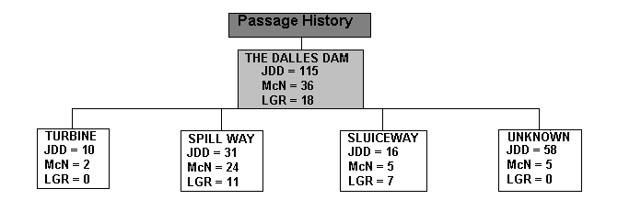
Figure 1. Passage histories (full and partial path) at The Dalles Dam for the radio-tagged groups from Lower Granite, McNary, and John Day dams.

Spillway
Overall, 67% (71/106) of radio-tagged kelts with full passage histories passed TDA during spill. Of these, 87% (62/71) passed via the spillway, 11% (8/71) through the sluiceway, and one kelt passed a turbine unit. During 30% spill, project kelt passage efficiency (KPE) was 99%. Kelt spillway efficiency (SE) was the above described 87% (62/ [62 + 8 + 1]), and spill effectiveness (SF) was 2.9:1 (0.87/0.30).

Powerhouse
Passage through turbine units was ancillary to spillway or sluiceway passage. Overall, KSLPE was 69% (27/[27+12]). The majority (77%; 27/35) of kelts that were contacted passing TDA during non-spill periods were from JDD. Most kelts (83%; 10/12) detected passing through turbine units at TDA were tagged and released at JDD.

Sluiceway occlusion test
Twenty-two kelts passed through the sluiceway during tests of turbine intake occlusion (blocked trash racks). Sluiceway passage was almost equally divided between occluded (55%; 12/22) and un-occluded periods (45%; 10/22). All (n=12) of the kelts that passed turbine units did so under occluded conditions.

Time of passage (diel)
Much (75%; 80/106) of kelt passage occurred during daytime hours (05:00-20:59). Most kelts (82%; 54/66) passed the spillway during the daytime. Similarly, many kelts passed the sluiceway (71%; 20/28) during daylight hours. Turbine passage was equally divided (50%; 6/12) between day and night periods.

Behavior
In the TDA forebay, telemetry data indicates that kelts displayed a greater tendency for searching and milling behavior (CNODC) during periods without spill (n=35) than during periods with spill (n=73; 3.5 versus 0.5 CNODC; Wilcoxon two-sample test, normal approximation, two-sided, DF = 34, P < 0.0001). Similarly, forebay residence times of kelts were significantly longer before spill (n=35) than during spill (n=71; 21:13 versus 4:59 means, 10:19 h versus 1:11 medians; Wilcoxon two-sample test, normal approximation, two-sided, DF = 34, P < 0.0001).
Passage - Bonneville Dam
At Bonneville Dam, complete passage histories were documented for 63% (133/212) of kelts released from McN and JDD dams (Figure 2.). Additionally, 4% (9/212) of the kelts released from LGR generated complete passage histories. Overall, 13% (19/142) of kelts were detected passing Powerhouse I, 24% (34/142) passed through the spillway, and 63% (89/142) of kelts were detected passing Powerhouse II.
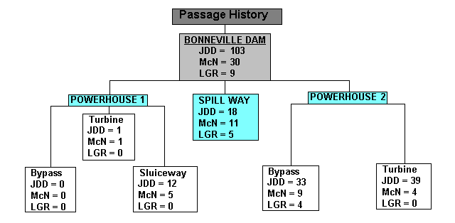

Figure 2. Passage histories (full and partial path) at Bonneville Dam for the radio-tagged groups from Lower Granite, McNary, and John Day dams.

Powerhouse I
Overall, 13% (19/142) of all the tagged kelts passed through PH I. All (n=17) of the kelts that passed through non-turbine routes passed through the ice and trash sluiceway. Kelt sluice passage efficiency at PH I was 89% (17 /[17 + 2]).

Powerhouse II
Of kelts with complete passage histories, 63% (89/142) were detected passing through PH II. Kelt guidance efficiency at PH II was 52% (46 /[46 + 43]).

Spillway
Overall, 24% (34/142) of kelts with complete passage histories were documented passing via the spillway.

Adult Attraction Spill - 2% (1 May- 15 May)
Prior to 37% spill, complete passage histories were documented for 52% (74/142) of kelts detected passing Bonneville Dam. Of these, 80% (59/74) passed through PH II and 20% (15/74) passed through PH I. During 2% spill, KPE was 54% (13 ^{PH I ITS} + 27 ^{PH II JBS} / [40 + 2^{PH I-TU} + 32^{PH II-TU}]). Most kelts 82% (61/74) passed the dam in the initial forebay they entered. Proportions of kelts entering forebay areas were similar to discharges through the areas. At PH I, the spillway, and PH II, 8%, 10%, and 82% of kelts initially entered the respective forebay areas (Figure 3).
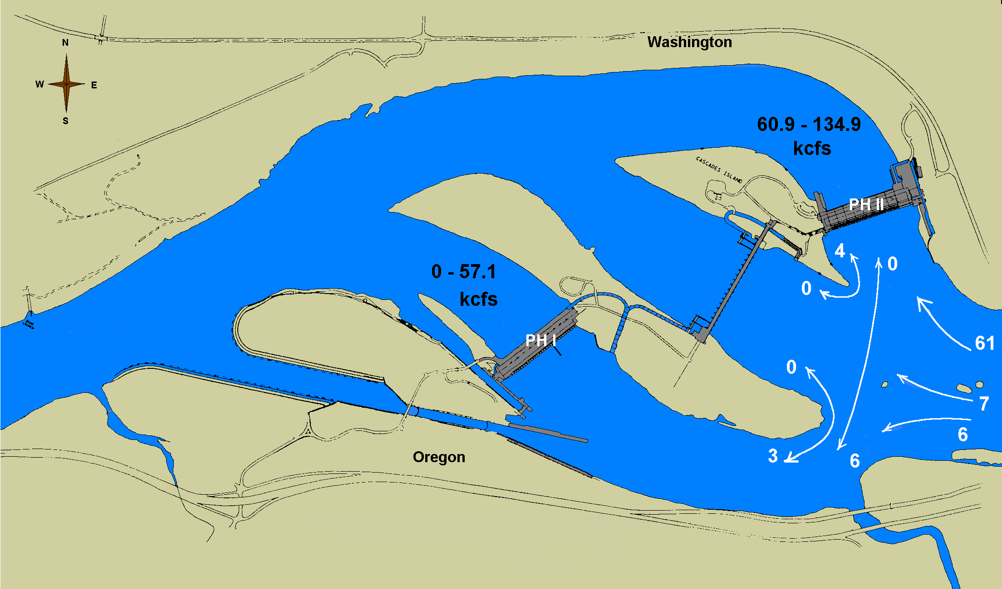

Figure 3. Number of radio-tagged kelts entering each forebay at Bonneville Dam during the weeks of adult attraction spill and the number that passed a different forebay than the one they entered. Shown are flow ranges for each forebay 1 April through 15 May.

Spill -37% (16 May -16 June)
During 37% spill, complete passage histories were produced for 48% (68/142) of kelts passing Bonneville Dam. Of these, 50% (34/68) passed through the spillway, 44% (30/68) passed through PH II, and 6% (4/68) passed through PH I. At PH II, kelt KGE was 63% (19 / [19 + 11]). At PH I, KSLPE was 100% (4 / [4 + 0]). Project kelt passage efficiency was 84% (34^{spill} + 4^{PH I ITS} + 19^{PH II JBS}/ [57 + 11^{PH II- TU}]). Spillway efficiency (SE) was 50% (34 / [57 + 11]), and spill effectiveness (SF) was 1.4 (0.5 / [0.37]).

Behavior
Overall, 63% (43/68) of kelts passed through the initial forebay they entered. Initial forebay entrance proportions at PH II, the spillway, and PH I were 74% (50/68), 25% (17/68), and 1% (1/68), respectively. Of the kelts that switched forebays during spill, there was a shift of 42% of kelts away from the PH II forebay. Most of these kelts passed through the spillway (Figure 4). Kelts passing via the spillway (n=34) had significantly shorter final forebay residence times than kelts passing via PH I (1:27 versus 4:02 means, 1:07 versus 2:57 medians; Wilcoxon two-sample; n=19; normal approximation, two-sided, DF = 18, P = 0.0036) or PH II (1:27 versus 8:27 means, 1:07 versus 3:46 medians; Wilcoxon two-sample; n=89; normal approximation, two-sided, DF = 33, P = 0.0014).

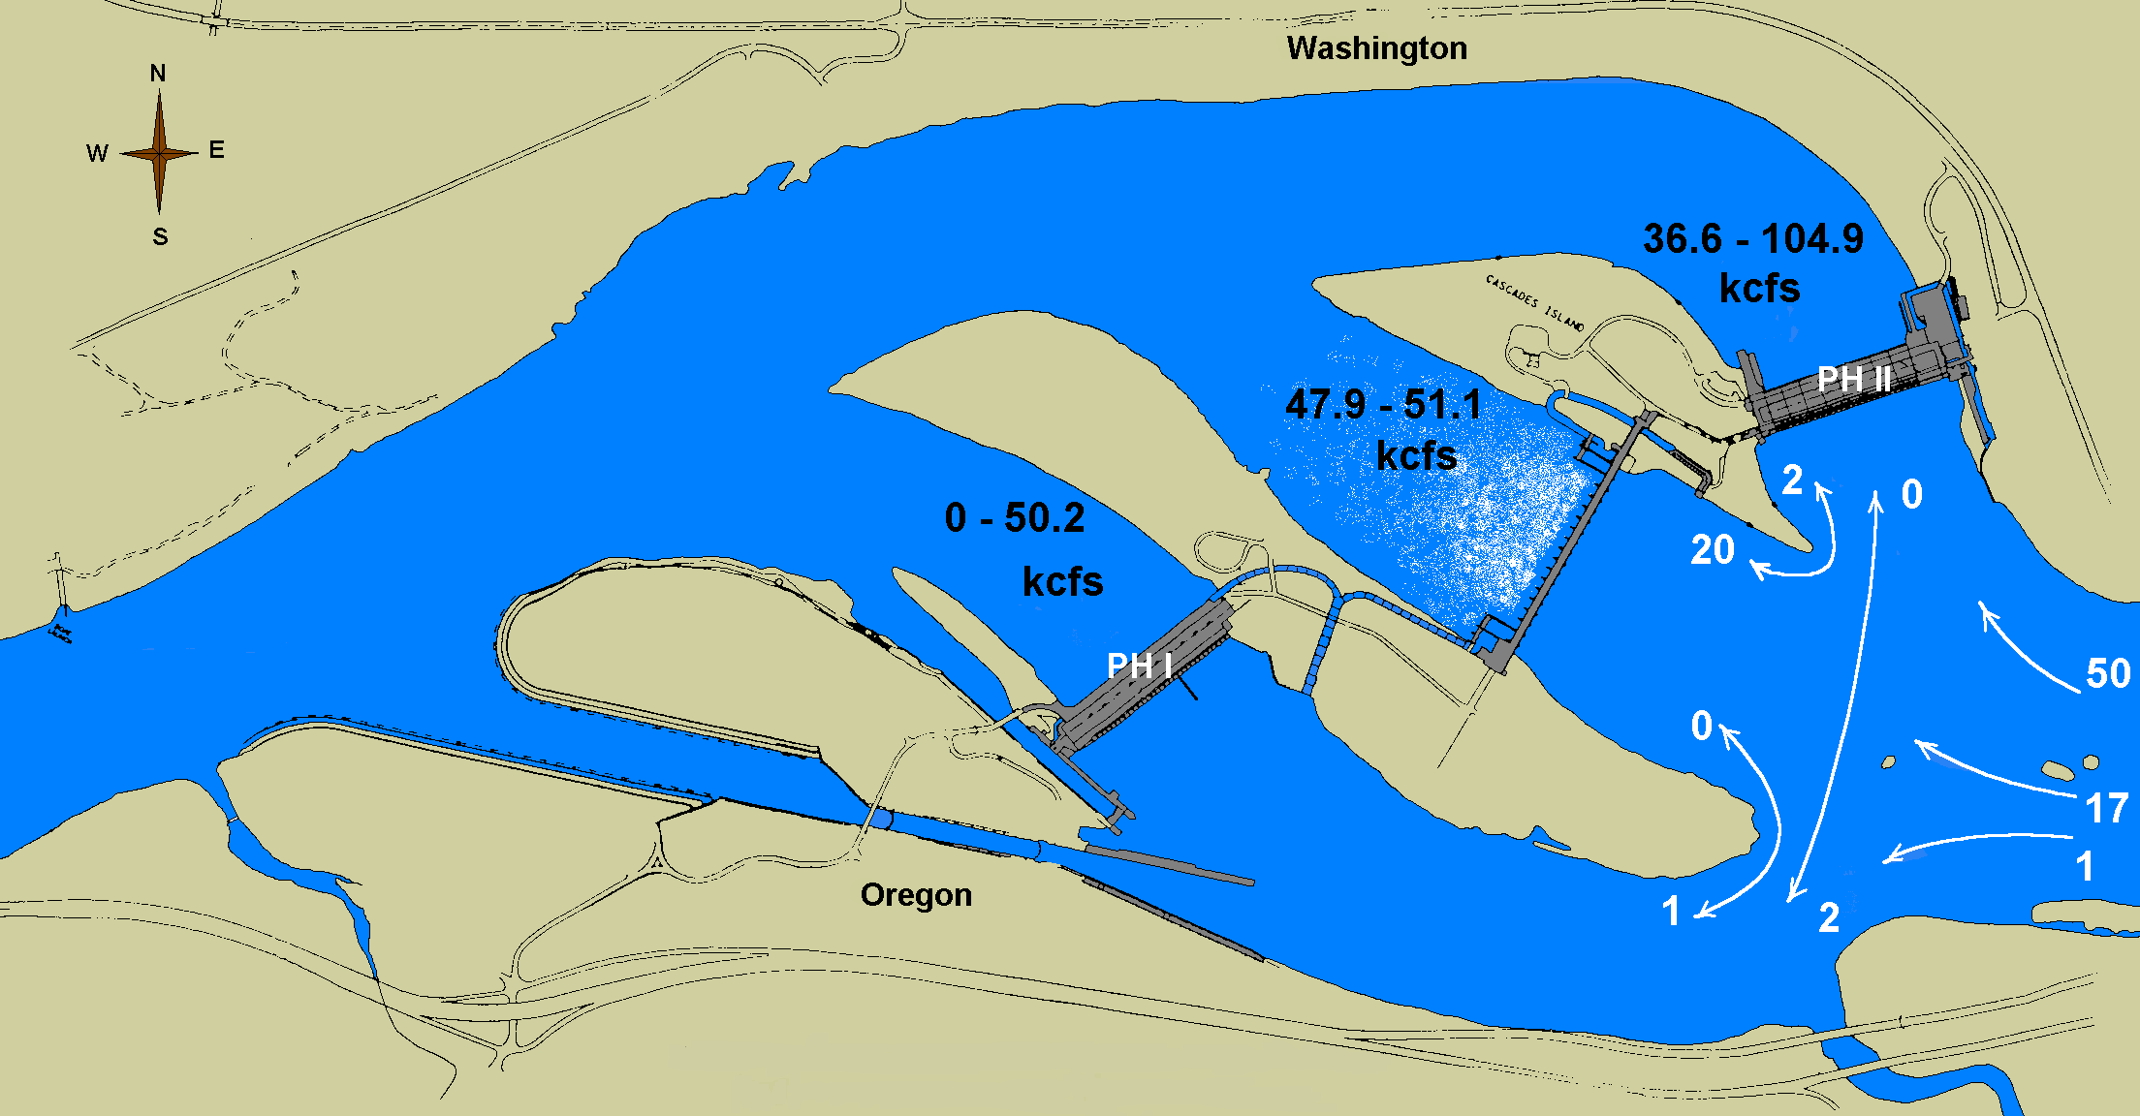

Figure 4. Number of radio-tagged kelts entering each forebay at Bonneville Dam during the weeks of spill and the number that passed a different forebay than the one they entered. Shown are flow ranges for each forebay 16 May through 16 June.

Time of passage (diel)
Most kelts 79% (112/142), passed through Bonneville Dam during daytime hours (05:00-20:59). At the PH I sluiceway, spillway, PH II JBS, and PH II turbine units daytime passage proportions were 76% (13/17), 80% (28/35), 81% (38/47), and 73% (33/45), respectively.

Conversion Rates
Conversion rates were disparate between kelts released in the Snake and Columbia Rivers. The majority of kelts released from LGR were not contacted in the Columbia River. Of the 212 kelts released from LGR, roughly, 3% (7/212) were contacted by the sets of telemetry survival gates below BON. Similarly, few (n=11) of the kelts released from LGR were documented passing McN. Four of the LGR kelts passed McN while FFU personnel were present, and none were recaptured at JDD.
Of the 53 kelts released from McN, 58% (31/53) were below BON. Similarly, of the 159 kelts released at JDD 64% (102/159) were detected below BON. At JDD, eleven of the radio-tagged and/or PIT tagged kelts released at McN were recaptured. Overall, contact rates for the three release groups at the projects, and through the sets of survival-gates can be observed in Figure 5.

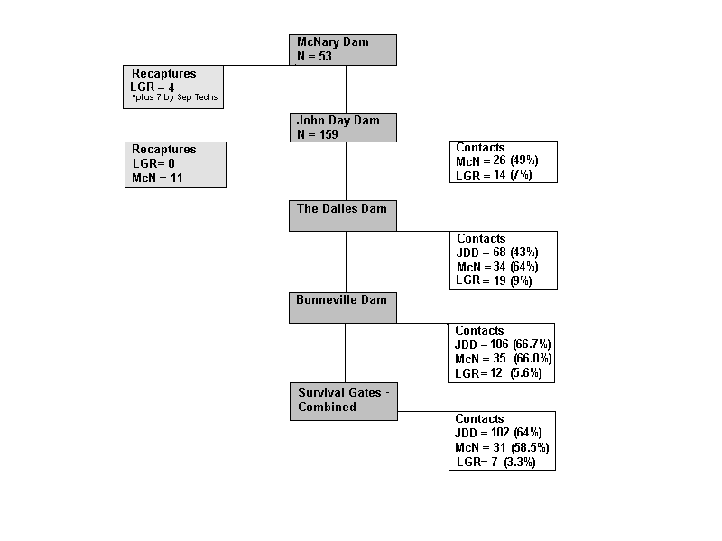

Figure 5. Conversion and recapture percentages for the radio-tagged groups from Lower Granite, McNary, and John Day dams. At The Dalles Dam, telemetry arrays were not operational for early releases of radio tagged kelts.

Radio-tag Retention
After tagging, 11% (6/53) of the radio-tagged kelts released back into the McN bypass were never subsequently contacted. Similarly, at JDD, 13% (21/159) of radio-tagged and released kelts were never contacted. During a study of kelt reconditioning, A. Evans (et al. 2001) found that within the first week there was roughly an 8% mortality rate of sampled (anesthesia, PIT-tagging) kelts.

To evaluate the in-river durability of our radio-tag harness, radio-tag retention rates were evaluated in the bypass facilities of projects below Lower Granite Dam (i.e., Little Goose, Lower Monumental, and McN dams). Kelts radio-tagged at LGR were visually marked (floy-tag) to allow evaluation of tag retention. Results from this test suggest that the majority (99%) of LGR released kelts retained their radio tags during outmigration through at least McNary Dam (Evans 2002).
To evaluate the period in which radio-tags remained affixed to kelts, hatchery kelts were dummy-tagged with methodology replicated at JDD. After tagging (PIT; dummy radio tags), kelts were transported in an 1100-liter trailer tank to the BON PH II SMF. Kelts were placed in 2 m circular tanks containing oxygenated river water. All kelts retained their tags for the first 33 days, after which, tags (n=3) were recovered after 34, 42, and 46 days, respectively (Appendix D). As median travel times for kelts released at McNary and John Day dams was 13.6, and 3.5 days, respectively, laboratory and in-river results suggest the majority of kelts released at McNary and John Day dams retained their radio-tags for the duration of the study.

Return Rates
For the period through September of 2002, nearly 8% (43/563) of kelts PIT tagged in 2001 have been detected ascending upstream through adult PIT tag interrogators located at BON, MCN and LGR dams. In 2001, PIT interrogations were not available from the A or B branch fishways of BON. Thus, reported return rates are not inclusive of all the steelhead that returned. That is, steelhead that passed BON PH I that were bound for tributaries below LGR on the Snake River, or the upper Columbia River were not detected. Returning steelhead, radio and PIT-tagged as kelts during their seaward migration, are providing information about the downstream dam passage routes of successfully returning fish. Returning steelhead have predominately passed through spillways, sluiceways, and bypass systems. Despite this, small sample sizes in returns from all the available passage routes inhibits our ability to make stronger statements on the affects of specific hydropower systems (e.g., turbine units) on steelhead return rates. This is especially true as some kelts that have passed one or more turbine units during downstream migration have returned to the Columbia River on upstream migrations

Project Summary and Discussion

Current kelt passage information indicates that kelts can be effectively routed past dams using surface flow bypass systems, sluiceways, and spill (Evans 2002, Wertheimer et al. 2001). These data suggest that protocols (e.g., spill) and facility modifications (e.g., surface-oriented bypass systems; Ferguson et al. 1998) employed to enhance juvenile project passage efficiencies and survival rates will prove beneficial for kelts. Continued development of surface flow bypass and collector systems in the FCRPS should enhance the collection, project passage efficiencies, effectiveness, and management scenarios available for Columbia Basin steelhead populations.

In 2001, spilling water significantly improved kelt travel rates through the monitored FCRPS projects and pools. Similarly, spill improved project passage efficiencies in the lower Columbia River. At TDA, the juvenile spill pattern (north spill) at a 30% spill discharge rate generated a kelt spill passage efficiency of 87%. Moreover, during spill, kelt project passage efficiency was 99%, and spill effectiveness was 2.9:1. Similarly, kelt passage efficiency at Bonneville Dam was over 80% during periods of 37% spill. Further work is needed to broaden our understanding of the passage efficacy and conversion (survival) of kelts through spillway’s under varying levels of spill.

The effects of blocking trash racks (occlusion) showed no benefits for kelt passage at TDA. Similarly, a past hydroacoustic evaluation showed no effect from occlusion at TDA on juvenile passage (Biosonics Inc. 1997). High reported sluiceway passage efficiencies for juveniles (as reviewed by Whitney et al. 1997), may suggest that little additional effectiveness can be attained through altering the sluiceway environ at TDA. In fact, increasing the flow field near the channel bottom (through blocking trash racks) may increase turbine passage rates for kelts. Further evaluations are scheduled to better determine the effects of occlusion on juvenile and kelt passage at TDA.

Current information warns of an inefficiency of standard length turbine intake screen systems in successfully guiding kelts away from turbine units in the FCRPS. Whether these data are a function of kelt turbine intake approach and passage behavior, or related to problems associated with gatewell orifice passage are unclear. Frequent injuries, apparently related to orifice passage, were reported in a study of adult fallbacks at McNary Dam (Wagner 1991). These data indicate gatewell orifice passage maybe problematic for adult salmonids. Additional study is needed on the orifice passage efficiencies of kelts and adult fallbacks.

Kelt detection rates, travel, and residence times could have been influenced by a variety of factors such as; transmitter loss, transmitter depth, transmitter burst rate, false positive detections (receiver detects the tag but the fish is actually dead), and kelt mortalities. Due to concealed factors such as delayed mortality and the potential for false-positive detections, we are unable to make broader statements regarding kelt survival. Whether initial kelt attrition rates (McN=11%; JDD=13%) were related to sampling, tag loss, tag failure, or negative affects of bypass outfall discharge (kelt injury or mortality associated with passing bypass system outfalls), or combinations of these factors are unknown. Tests of radio-tag retention suggest that tag loss was probably minimal. However, tag retention of kelts passing turbine units and spillways (bypass systems were sampled) remains invalidated. To ensure contact attritions are not related to radio-tag loss, future studies will use a more robust suture material (e.g., nylon), with tests of tag retention replicated.

Adult PIT detection technologies were effective for monitoring returns, as indicated by the percentage of steelhead contacted on upstream migrations (~ 8%). These data are reflective of returns from kelts in good and fair condition. Documented returns are undoubtedly a conservative indicator of returns, as only the Washington Shore fishway of BON and the adult trap of LGR recorded PIT detections in 2001. Beyond 2002, additional adult PIT detection systems (e.g., all fishladders of BON, McN, Ice Harbor, and Priest Rapids dams) will allow for a more comprehensive evaluation of steelhead returns. In addition, these detection systems will document return rates from the differing steelhead evolutionarily significant units within the Columbia Basin.

The high attrition rate of kelts released in the Snake River relative to Columbia River releases suggests differing kelt management protocols are probably suitable for these areas. Further work is needed to determine what methodologies (e.g., transport, reconditioning, short term reconditioning and transport, improved in-river passage) may be most appropriate (by stock and location) for conserving and deriving a greater benefit from the life history characteristics of this species. Toward this end, further investigations are scheduled on the passage routes, rates, and returns from kelt populations passing through the FCRPS, and potential actions to mitigate for the effects of passing pools and dams on steelhead iteroparity rates.

Acknowledgements

This project was funded by the U.S. Army Corps of Engineers, Portland and Walla Walla Districts, under the Northwest Division’s Anadromous Fisheries Evaluation Program (AFEP). We are thankful for the efforts of the project officers, David Clugston and Mike Langeslay. We also thank Corps Biologists Brad Eby at McNary Dam, and Bob Cordie at John Day Dam for their generous assistance during fieldwork at their projects. Without their and their staff’s efforts, these works would not be possible.

We are indebted for the collaborative efforts and telemetry data collection from the USGS staff of the Columbia River Research laboratory. Special thanks are warranted to Noah Adams, John Beeman, Scott Evans, Dennis Rondorf, and Rachel Wardell. Similarly, Sarah McCarthy (NMFS NWFSC), Chris Peery (UI), and Ken Tolloti (UI) all provided significant contributions in data collection and transfer. We also thank Robert Stansell for coordinating logistics and his thoughtful review. We were very grateful for support from the late Dr. Theodore Bjorrn.

References

Beeman, J. W., H. C. Hansel, P. V. Haner and J. Hardiman. Estimates of Fish-, Spill-, and Sluiceway-Passage Efficiencies of Radio-Tagged Juvenile Steelhead and Yearling Chinook Salmon at The Dalles Dam, 2000 interim report of research. Prepared by the U.S. Geological Survey, Cook Washington for the U.S. Army Corps of Engineers, Portland District, Portland, OR, USA.

Biosonics Inc. 1997. Hydroacoustic evaluation and studies at The Dalles Dam, spring/summer 1997. Volume I – Fish Passage. Report to U.S. Army Corps of Engineers, Portland District, 64 p. Plus appendixes. Available from Biosonics, Inc., Leary Way N.W., Seattle, WA 98107.

Brown, R.S., S.J. Cook, W.G. Anderson, and R.S. McKinley. 1999. Evidence to Challenge the “2% Rule” for Biotelemetry. North American Journal of Fisheries Management 19: 867-871.

Burnham, K.P., D.R. Anderson, G.C. White, C. Brownie, and K.H. Pollock. 1987.
Design and analysis methods for fish survival experiments based on release-recapture. American Fisheries Society Monograph 5; ISSN 0362-1715.

Coutant, C.C. and R.R. Whitney. 2000. Fish behavior in relation to passage through hydropower turbines: a review. Transactions of the American Fisheries Society 129:351-380.

Elston, R. 1996. Investigation of Head Burns in Adult salmonids. Phase 1: Examination of fish at Lower Granite Dam, July 2, 1996. 12p. Final report prepared for the Bonneville Power Administration. Contract number 96AP95973.

Evans, A.F. 2002. Steelhead (Oncorhynchus mykiss) kelt outmigrations from Lower Granite Dam to Bonneville Dam: Abundance, downstream conversion rates, routes of passage, and travel times. Annual Report To US Army Corps of Engineers, Walla Walla District, for Contract No. DACW68-01-0016. Prepared by CRITFC, Portland, OR.

Evans, A.F., R.E. Beaty, D.R. Hatch, J.B. Blodgett, and D. Fast. 2001. Kelt reconditioning: a research project to enhance iteroparity in Columbia Basin steelhead (Oncoryhnchus mykiss). Draft Report To Bonneville Power Administration, for Project 2000-017. Prepared by CRITFC, Portland Or.

Evans, A.F., and R.E. Beaty. Identification and enumeration of steelhead (Oncorhynchus mykiss) kelts in the juvenile collection systems at Lower Granite and Little Goose dams, 2000. In U.S. Army Corps of Engineers. Anadromous fish evaluation program: 2000 annual research review. Portland District, Portland, Oregon.

Ferguson, J.E., T.P. Poe, and T.J. Carlson. 1998. Surface-oriented bypass systems for juvenile salmonids on the Columbia River, USA. In Fish Migration and Fish Bypasses. Ed. M. Jungwirth, S. Schmutz, and S. Weiss. pp. 281-299.

Giorgi, A.E, M. Miller, and J.R. Stevenson. 2002. Mainstem passage strategies in the Columbia River system: Transportation, spill, and flow augmentation. Bioanalysts: for Northwest Power Planning Council, Portland, Oregon.

ISG (Independent Science Group). 1996. Return to the river: restoration of salmonid fishes in the Columbia River. ISG, Report 96-6, for NPPC Portland, Oregon.

Kelly, J.E., and N.S. Adams. 1996. Range tests on radio tags considered for use in Lower Granite Reservoir, Washington. Pages 14-29 in D.W. Rondorf and M. J. Banach editors. Migrational characteristics of juvenile spring Chinook salmon and steelhead in lower Granite Reservoir and tributaries, Snake River. Report to U.S. Army Corps of Engineers, Contract E 86930151, Walla Walla, Washington.

Leider, S.A. 1985. Precise timing of upstream migrations by repeat steelhead spawners. Transactions of the American Fisheries Society 114:906–908.

NMFS. (National Marine Fisheries Service). 1998. Supplemental Biological Opinion. NMFS Northwest Region. Seattle, WA.

NMFS. (National Marine Fisheries Service) 2000a. Biological Opinion. NMFS Northwest Region. Seattle, WA.

NMFS. (National Marine Fisheries Service) 2000b. White Paper. Passage of Juvenile and Adult Salmonids past Columbia and Snake River Dams. NMFS, Seattle, WA.

NWPPC (Northwest Power Planning Council). 1986. Compilation of information on salmon and steelhead losses In the Columbia River basin. Appendix D In 1987 Columbia River fish and wildlife program. NWPCC, Portland, Or.

Prince, A. and C. Powell. 2000. Clove oil as an anesthetic for invasive field procedures on adult rainbow trout. North American Journal of Fisheries Management 20: 1029-1032.

Shively, R. S., T. P. Poe, and M. B. Sheer. 1996. Criteria for reducing predation by northern squawfish near juvenile salmonid bypass outfalls at Columbia River dams. Regulated Rivers Research and Management 12:493-500.

Wagner, P. 1990 Evaluation of the use of the McNary bypass system to divert adult fallbacks away from turbine intakes. Report of research by Washington Department of Fisheries to U.S. Army Corps of Engineers.

Wertheimer R.H., J.T. Dalen, and P.L. Madson. 2001. Evaluation of steelhead kelt passage routes at Bonneville Dam, in 2000. U.S. Army Corps of Engineers, Portland District Fish Field Unit, Bonneville Lock and Dam, Cascade Locks, Or. 26 pp.

Whitney, R. R., L. D. Calvin, M. W. Erho, Jr., and C. C. Coutant. 1997. Downstream passage for salmon at hydroelectric projects in the Columbia River Basin: development, installation, and evaluation. Prepared for the Northwest Power Planning Council, Portland, Oregon, USA. #97-15.

Zar, J.H. 1996. Biostatistical Analysis. Prentice Hall, Inc. Englewood Cliffs, New Jersey.

Appendix A

Table A-1. Summary of the sample date, sample size (n), sample mean, standard deviation (SD), fork length (cm), sex, origin, ultrasound diagnostic, and recaptures of steelhead at McNary Dam in spring of 2001.

McNary Sample  Date n |  | Fork Length (cm)  Mean SD Range |  |  | Sex  M F UN |  |  | Origin  Wild Hatch |  | Ultrasound  Pre Kelt |  | Recaps  LGR
April 3 | 6 | 55.3 | 2.2 | 53-58 | 1 | 4 | 1 | 4 | 2 | 3 | 3 | 0
April 4 | 3 | 55.3 | 8.7 | 48-65 | 0 | 0 | 3 | 3 | 0 | 0 | 3 | 0
April 7 | 11 | 66.9 | 10.4 | 49-79 | 1 | 9 | 1 | 7 | 4 | 6 | 5 | 0
April 10 | 14 | 64.6 | 4.3 | 57-72 | 2 | 8 | 4 | 11 | 3 | 8 | 6 | 0
April 13 | 28 | 63.7 | 7.8 | 39-74 | 3 | 18 | 7 | 20 | 8 | 12 | 16 | 0
April 17 | 5 | 64.8 | 6.2 | 54-70 | 2 | 2 | 1 | 4 | 1 | 0 | 5 | 0
April 18 | 18 | 61.9 | 8.5 | 42-72 | 1 | 13 | 4 | 11 | 7 | 5 | 13 | 0
April 20 | 13 | 63.9 | 9.1 | 55-74 | 0 | 11 | 2 | 8 | 5 | 2 | 11 | 0
April 24 | 12 | 63.9 | 9.1 | 53-76 | 1 | 5 | 6 | 6 | 6 | 2 | 10 | 0
April 25 | 10 | 65.3 | 6.7 | 59-78 | 0 | 5 | 5 | 6 | 4 | 1 | 9 | 0
April 27 | 8 | 63.1 | 5.9 | 57-74 | 1 | 7 | 0 | 4 | 4 | 1 | 7 | 0
May 1 | 12 | 63.1 | 7.3 | 53-72 | 0 | 4 | 8 | 6 | 6 | 2 | 10 | 0
May2 | 23 | 63.5 | 8.5 | 45-77 | 2 | 9 | 12 | 6 | 17 | 3 | 20 | 0
May 4 | 11 | 60.7 | 5.0 | 54-70 | 1 | 8 | 2 | 6 | 5 | 0 | 11 | 0
May 8 | 10 | 61.5 | 5.9 | 55-69 | 0 | 5 | 5 | 7 | 3 | 1 | 9 | 0
May 9 | 9 | 55.4 | 7.2 | 44-66 | 0 | 4 | 5 | 7 | 2 | 0 | 9 | 0
May 11 | 11 | 61.5 | 6.9 | 54-72 | 0 | 10 | 1 | 10 | 1 | 1 | 10 | 0
May 15 | 14 | 61.5 | 8.9 | 41-79 | 1 | 8 | 5 | 5 | 9 | 1 | 13 | 0
May 16 | 35 | 60.7 | 6.4 | 42-70 | 0 | 21 | 14 | 21 | 14 | 3 | 32 | 0
May 18 | 21 | 60.1 | 5.3 | 52-71 | 1 | 14 | 6 | 14 | 7 | 1 | 20 | 0
May 22 | 31 | 61.3 | 7.0 | 49-72 | 1 | 14 | 15 | 18 | 12 | 2 | 28 | 1
May 23 | 30 | 59.1 | 6.4 | 49-72 | 2 | 11 | 15 | 12 | 16 | 1 | 27 | 2
May 25 | 17 | 64.0 | 7.0 | 51-75 | 0 | 16 | 1 | 9 | 8 | 0 | 17 | 0
May 29 | 15 | 60.3 | 6.5 | 52-80 | 0 | 8 | 7 | 11 | 4 | 0 | 15 | 0
May 30 | 11 | 63.4 | 8.7 | 51-76 | 0 | 3 | 7 | 6 | 4 | 0 | 10 | 1
June 1 | 9 | 62.1 | 7.5 | 54-76 | 0 | 7 | 2 | 7 | 2 | 0 | 9 | 0
Total | 387 | ---- | ---- | ---- | 20 | 224 | 139 | 229 | 154 | 55 | 328 | 4

- Recaptured tagged fish from LGR in these samples did not go through analysis again therefore data variables were not recorded.
- Data recorded for fish that were not evaluated with ultrasound (visual only fish) by FFU are not included in the data set.

Table A-2 Summary of the sample date, sample size (n), mean, standard deviation (SD), fork length (cm), sex, origin, ultrasound diagnostic, and recaptures of steelhead at John Day Dam in the spring of 2001.

John Day Sample  Date n |  | Fork Length (cm)  Mean SD Range |  |  | Sex  M F UN |  |  | Origin  Wild Hatch |  | Ultrasound  Pre Kelt |  | Recaps  McN
Mar 30 | 8 | 71.00 | 0.0 | 71 – 71 | 1 | 7 | 0 | 2 | 6 | 6 | 2 | 0
Mar 31 | 19 | 61.67 | 11.9 | 26 – 82 | 2 | 8 | 9 | 12 | 7 | 9 | 10 | 0
April 1 | 10 | 62.44 | 12.8 | 47 – 84 | 1 | 7 | 2 | 5 | 5 | 4 | 6 | 0
April 2 | 11 | 64.09 | 4.5 | 55 – 69 | 0 | 3 | 8 | 8 | 3 | 2 | 9 | 0
April3 | 9 | 65.22 | 9.0 | 47 – 76 | 2 | 2 | 5 | 6 | 3 | 3 | 6 | 0
April 4 | 18 | 67.06 | 8.9 | 55 – 89 | 1 | 7 | 10 | 12 | 6 | 6 | 12 | 0
April 5 | 20 | 65.00 | 9.2 | 48 – 80 | 1 | 11 | 8 | 14 | 6 | 3 | 17 | 0
April 9 | 16 | 66.18 | 6.2 | 53 – 75 | 1 | 12 | 3 | 13 | 3 | 1 | 15 | 0
April 10 | 20 | 65.75 | 6.1 | 50 – 74 | 2 | 8 | 10 | 17 | 3 | 3 | 17 | 0
April 11 | 25 | 67.92 | 7.3 | 55 – 86 | 3 | 10 | 12 | 18 | 7 | 6 | 19 | 0
April 12 | 29 | 64.17 | 6.1 | 53 – 75 | 1 | 5 | 23 | 17 | 12 | 0 | 29 | 0
April 16 | 31 | 62.94 | 5.7 | 53 – 76 | 1 | 17 | 13 | 20 | 11 | 4 | 27 | 0
April 17 | 31 | 63.29 | 7.1 | 52 – 75 | 3 | 11 | 17 | 22 | 9 | 7 | 24 | 0
April 18 | 33 | 66.09 | 6.2 | 55 – 82 | 1 | 14 | 18 | 25 | 8 | 2 | 31 | 0
April 19 | 43 | 64.26 | 7.2 | 46 – 78 | 3 | 26 | 14 | 25 | 18 | 3 | 40 | 0
April 23 | 25 | 61.08 | 6.6 | 51 – 72 | 0 | 14 | 11 | 19 | 6 | 2 | 23 | 0
April 24 | 41 | 65.98 | 5.7 | 56 – 78 | 5 | 22 | 14 | 34 | 7 | 7 | 34 | 0
April 25 | 43 | 62.44 | 8.0 | 45 – 81 | 2 | 25 | 16 | 31 | 12 | 2 | 41 | 0
April 26 | 72 | 63.07 | 7.6 | 49 – 82 | 5 | 59 | 8 | 51 | 21 | 5 | 67 | 0
April 30 | 41 | 61.59 | 7.8 | 48 – 85 | 0 | 25 | 16 | 33 | 8 | 2 | 39 | 0
May 1 | 51 | 61.10 | 6.8 | 48 – 83 | 2 | 31 | 17 | 32 | 18 | 2 | 48 | 1
May 2 | 41 | 62.44 | 7.6 | 52 – 81 | 1 | 30 | 10 | 31 | 10 | 4 | 37 | 0
May 7 | 53 | 60.29 | 6.2 | 52 – 77 | 3 | 36 | 15 | 39 | 15 | 2 | 49 | 2
May 8 | 41 | 60.24 | 7.8 | 42 – 73 | 1 | 26 | 14 | 32 | 9 | 0 | 41 | 0
May 9 | 27 | 59.96 | 6.6 | 47 – 73 | 0 | 18 | 9 | 20 | 7 | 2 | 24 | 1
May 10 | 32 | 60.94 | 6.4 | 47 – 72 | 4 | 21 | 7 | 24 | 8 | 3 | 28 | 1
May 14 | 23 | 59.41 | 5.1 | 54 – 70 | 0 | 14 | 9 | 19 | 4 | 0 | 23 | 0
May 15 | 23 | 60.35 | 6.5 | 50 – 75 | 3 | 12 | 8 | 19 | 4 | 0 | 23 | 0
May 16 | 34 | 60.09 | 6.4 | 48 – 74 | 1 | 23 | 10 | 27 | 7 | 2 | 32 | 0
May 17 | 62 | 59.68 | 6.8 | 50 – 76 | 5 | 29 | 28 | 54 | 8 | 1 | 61 | 0
May 21 | 64 | 58.71 | 8.0 | 43 – 85 | 1 | 44 | 19 | 49 | 15 | 0 | 63 | 1
May 22 | 46 | 58.35 | 5.9 | 46 – 74 | 3 | 24 | 19 | 41 | 5 | 2 | 44 | 0
May 23 | 63 | 61.05 | 6.6 | 48 – 75 | 2 | 41 | 20 | 47 | 16 | 0 | 61 | 2
May 24 | 44 | 61.09 | 8.5 | 47 – 81 | 4 | 25 | 15 | 35 | 9 | 4 | 40 | 0
May 29 | 8 | 62.75 | 5.7 | 55 – 69 | 0 | 5 | 3 | 5 | 3 | 0 | 8 | 0
May 30 | 10 | 61.80 | 4.9 | 55 – 70 | 1 | 6 | 3 | 9 | 1 | 0 | 10 | 0
May 31 | 16 | 60.13 | 6.3 | 50 – 73 | 1 | 6 | 9 | 12 | 4 | 0 | 15 | 1
June 4 | 3 | 56.33 | 3.2 | 54 – 60 | 1 | 0 | 2 | 2 | 1 | 0 | 3 | 0
June 5 | 2 | 54.00 | 2.8 | 52 – 56 | 1 | 1 | 0 | 2 | 0 | 0 | 2 | 0
June 6 | 5 | 66.20 | 4.5 | 63 – 74 | 0 | 5 | 0 | 1 | 4 | 0 | 5 | 0
June 20 | 14 | 60.21 | 7.4 | 52 – 74 | 3 | 7 | 4 | 7 | 7 | 3 | 11 | 0
Total | 1207 | --- | --- | --- | 72 | 697 | 438 | 891 | 316 | 102 | 1096 | 9

- Recaptured radio- tagged fish from McN in these samples did not go through analysis again, therefore, no data variables were recorded. There were no recaptures from LGR at JDD. Data recorded for fish that were not were not evaluated with ultrasound (visual only fish) are not included in the data set.

Figure A-1. Weekly proportion of the total steelhead population sampled at the smolt monitoring facility at John Day Dam, Columbia River 2001. Assuming equal distribution.

Figure A-2. Weekly proportion of the total steelhead population sampled at the juvenile fish facility separator of McNary Dam, Columbia River 2001. Assuming equal distribution.

Appendix B

Table B-1. Summary of the collection location, date, sample size (n), sample mean, standard deviation
(SD), fork length (cm), sex, and origin of radio-tagged steelhead kelts in 2001.

Collection  Site/Tag Date | n | Fork Length (cm)  Mean SD Range |  |  | Sex  M F UN |  |  | Origin
 |  |  |  |  |  |  |  | Wild |  | Hatch
MCN 17-April | 1 | 67.0 | ** | 67 | 0 | 1 | 0 | 1 | 0
MCN 18-April | 6 | 63.8 | 7.7 | 53 – 71 | 0 | 4 | 2 | 5 | 1
MCN 20-April | 5 | 62.8 | 7.1 | 55 – 71 | 0 | 4 | 1 | 4 | 1
JDD 23-April | 14 | 62.5 | 7.6 | 51 – 74 | 0 | 7 | 7 | 10 | 4
MCN 24-Ap | 2 | 72.5 | 4.9 | 69 - 76 | 0 | 2 | 0 | 0 | 2
JDD 25-April | 21 | 63.4 | 6.1 | 51 – 73 | 0 | 13 | 8 | 21 | 0
JDD 26-April | 20 | 64.8 | 6.8 | 57 – 74 | 0 | 17 | 3 | 15 | 5
MCN 27-April | 5 | 64.5 | 6.2 | 54 – 70 | 0 | 5 | 0 | 3 | 2
JDD 30-April | 13 | 64.5 | 6.2 | 54 – 70 | 0 | 7 | 6 | 12 | 1
JDD 1-May | 8 | 63.1 | 5.6 | 54 – 69 | 0 | 7 | 1 | 5 | 3
JDD 2-May | 7 | 63.4 | 8.8 | 52 – 81 | 0 | 7 | 0 | 4 | 3
MCN 4-May | 7 | 61.4 | 4.9 | 55 – 70 | 0 | 6 | 1 | 4 | 3
JDD 7-May | 17 | 64.8 | 9.0 | 52 – 87 | 0 | 16 | 1 | 13 | 4
JDD 8-May | 10 | 65.6 | 6.1 | 56 – 73 | 0 | 9 | 1 | 9 | 1
JDD 9-May | 5 | 57 | 6.4 | 58 – 73 | 0 | 3 | 2 | 4 | 1
MCN 11-May | 5 | 59.8 | 7.0 | 54 – 72 | 0 | 5 | 0 | 5 | 0
JDD 14-May | 5 | 58 | 3.9 | 54 – 64 | 0 | 4 | 1 | 5 | 0
JDD 15-May | 6 | 62.8 | 5.9 | 55 – 70 | 0 | 2 | 4 | 6 | 0
JDD 16-May | 4 | 60.8 | 5.7 | 56 – 69 | 0 | 3 | 1 | 4 | 0
MCN 18-May | 6 | 59 | 5.0 | 53 – 69 | 0 | 5 | 1 | 5 | 1
JDD 21-May | 5 | 63.5 | 12.5 | 55 – 85 | 0 | 3 | 2 | 4 | 1
JDD 23-May | 8 | 61.6 | 6.3 | 53 – 70 | 0 | 6 | 2 | 6 | 2
MCN 25-May | 10 | 65.1 | 5.2 | 56 – 72 | 0 | 10 | 0 | 5 | 5
JDD 30-May | 4 | 64.3 | 5.6 | 59 – 70 | 1 | 1 | 2 | 4 | 0
JDD 31-May | 5 | 62.6 | 5.8 | 54 – 69 | 0 | 2 | 3 | 4 | 1
MCN 01-June | 6 | 62.3 | 8.8 | 54 – 76 | 0 | 6 | 0 | 5 | 1
JDD 04-June | 2 | 57.5 | 3.5 | 55 – 60 | 1 | 0 | 1 | 1 | 1
JDD 06-June | 4 | 67 | 4.8 | 64 –74 | 0 | 4 | 0 | 1 | 3
JDD 20-June | 1 | 71 | ** | 71 | 1 | 0 | 0 | 1 | 0
Overall: | 212 | 63.1 | 8.0 | 51 – 87 | 3 | 159 | 50 | 166 | 46

Summary of UI fixed site aerial and underwater receiver/antenna telemetry arrays. Arrays were operated and maintained by University of Idaho. Data from these locations forwarded to the Fisheries Field Unit and CRITFC.

University of Idaho fixed stations.

Site | Antennas | RKM | Receiver | Description
1BO | 1 | 232.3 | SRX | Washington shore at the Hamilton Island boat ramp
2BO | 1 | 232.3 | SRX | Oregon shore across from the Hamilton Island boat ramp
SBO | 1 | 235.3 | SRX | Forebay above spillway, north shore facing south
BF2 | 1-5 | 235.2 | SRX | Bonneville Spillway Forebay
BF3 | 1-4 | 235.2 | SRX | Bonneville Spillway Forebay
FTR | 1 | 235.3 | DSP | Washington shore, Ft Rains
BOG | 1 | 238.6 | DSP | Bridge of the Gods, at Cascade Locks
WIN | 1 | 249.2 | DSP | Wind River, Wind River boat launch
UPA | 1 | 246.6 | DSP | Oregon shore, across from Depot Road
DPR | 1 | 246.6 | DSP | Washington shore, Depot Road, downstream from Wind River
LWD | 1 | 260.1 | DSP | Washington shore, downstream from Little White Salmon River
LWS | 1 | 261 | DSP | Little White Salmon, inside at mouth of Drano Lake
LWU | 1 | 261.3 | DSP | Washington shore upstream from Little White Salmon River
WHD | 1 | 270.3 | DSP | Washington shore, downstream from White Salmon River
WHR | 1 | 270.9 | DSP | White Salmon River, landing at mouth
WSU | 1 | 272.5 | DSP | White Salmon River, upstream from WHR
HDR | 1 | 272.6 | DSP | Hood River
BMA | 1 | 276.4 | DSP | Washington shore, Bingen Marina

USGS Telemetry Site Maps

The Dalles Dam

Appendix C
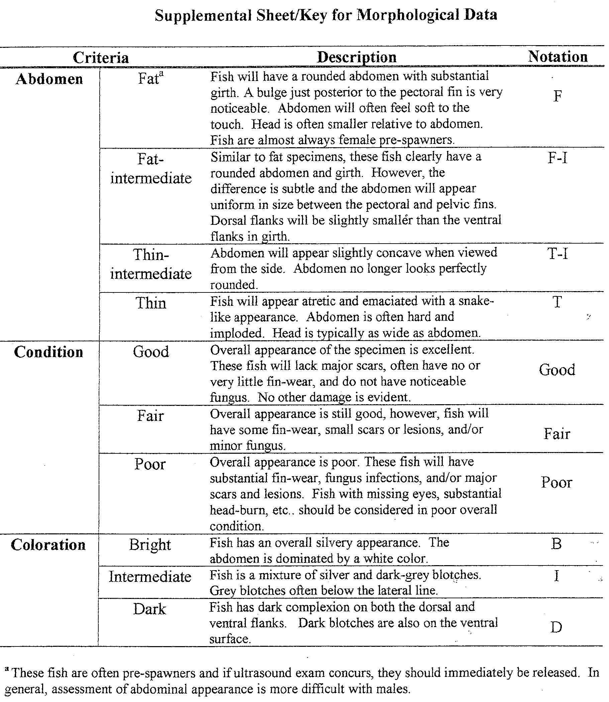

Appendix D

Tag Retention Test Results

The number of days radio tags remained affixed to kelts held in fresh water tanks at the Bonneville PH II SMF.

Tag Date | PIT tag | Date | Disposition | Tag | # of days
25-Apr | 3D9.1BF10D1B87 | 13-May | MORT | SECURE
25-Apr | 3D9.1BF10CB452 | 06-Jun | LIVE | OFF | 42
25-Apr | 3D9.1BF10D054B | 29-May | LIVE | OFF | 34
25-Apr | 3D9.1BF10D51A7 | 30-Apr | MORT | SECURE
25-Apr | 3D9.1BF10CA1F1 | 02-May | MORT | SECURE
25-Apr | 3D9.1BF10CF68A | 07-May | MORT | SECURE
25-Apr | 3D9.1BF10CAF18 | 07-May | MORT | SECURE
25-Apr | 3D9.1BF10D96DE | 10-Jun | LIVE | OFF | 46
25-Apr | 3D9.1BF10D780F | 21-May | MORT | SECURE
25-Apr | 3D9.1BF1OCCC20 | 13-May | MORT | SECURE
25-Apr | 3D9.1BF10D742F | 06-May | MORT | SECURE
16-May | 3D9.1BF10CBDF2 | 21-May | MORT | SECURE
16-May | 3D9.1BF10D37B1 | 29-May | MORT | SECURE
16-May | 3D9.1BF10D7387 | 29-May | MORT | SECURE
16-May | 3D9.1BF10D6AAB | 25-May | MORT | SECURE
16-May | 3D9.1BF10CB413 | 29-May | MORT | SECURE
16-May | 3D9.1BF10CA978 | 30-May | MORT | SECURE

Appendix E – Occlusion Test Schedule at The Dalles
 | Julian |  |  | Study |  | Julian |  |  | Study
Date | Day | Day | Treatment | Day | Date | Day | Day | Treatment | Day
4/20 | 110 | Fri | Transition | 1 | 6/1 | 152 | Fri | Transition | 43
4/21 | 111 | Sat | Transition | 2 | 6/2 | 153 | Sat | Unoccluded | 44
4/22 | 112 | Sun | Transition | 3 | 6/3 | 154 | Sun | Unoccluded | 45
4/23 | 113 | Mon | Transition | 4 | 6/4 | 155 | Mon | Trans MU4-3 unocc | 46
4/24 | 114 | Tue | Occluded | 5 | 6/5 | 156 | Tue | Occluded "" | 47
4/25 | 115 | Wed | Occluded | 6 | 6/6 | 157 | Wed | Occluded "" | 48
4/26 | 116 | Thu | Occluded | 7 | 6/7 | 158 | Thu | Occluded | 49
4/27 | 117 | Fri | Occluded | 8 | 6/8 | 159 | Fri | Occluded | 50
4/28 | 118 | Sat | Occluded | 9 | 6/9 | 160 | Sat | Occluded | 51
4/29 | 119 | Sun | Occluded | 10 | 6/10 | 161 | Sun | Occluded | 52
4/30 | 120 | Mon | Transition | 11 | 6/11 | 162 | Mon | Occluded | 53
5/1 | 121 | Tue | Unoccluded | 12 | 6/12 | 163 | Tue | Occluded | 54
5/2 | 122 | Wed | Unoccluded | 13 | 6/13 | 164 | Wed | Occluded | 55
5/3 | 123 | Thu | Unoccluded | 14 | 6/14 | 165 | Thu | Occluded | 56
5/4 | 124 | Fri | Unoccluded | 15 | 6/15 | 166 | Fri | Occluded | 57
5/5 | 125 | Sat | Transition | 16 | `1 | 167 | Sat | Occluded | 58
5/6 | 126 | Sun | Occluded | 17 | 6/17 | 168 | Sun | Occluded | 59
5/7 | 127 | Mon | Occluded | 18 | 6/18 | 169 | Mon | Occluded | 60
5/8 | 128 | Tue | Occluded | 19 | 6/19 | 170 | Tue | Occluded | 61
5/9 | 129 | Wed | Occluded | 20 | 6/20 | 171 | Wed | Occluded MU 4-3 out | 62
5/10 | 130 | Thu | Occluded | 21 | 6/21 | 172 | Thu | Occluded | 63
5/11 | 131 | Fri | Transition | 22 | 6/22 | 173 | Fri | Occluded | 64
5/12 | 132 | Sat | Unoccluded | 23 | 6/23 | 174 | Sat | Occluded | 65
5/13 | 133 | Sun | Unoccluded | 24 | 6/24 | 175 | Sun | Occluded | 66
5/14 | 134 | Mon | Trans MU 3-3 Un | 25 | 6/25 | 176 | Mon | Occluded | 67
5/15 | 135 | Tue | Occluded "" | 26 | 6/26 | 177 | Tue | Occluded | 68
5/16 | 136 | Wed | Occluded "" | 27 | 6/27 | 178 | Wed | Occluded | 69
5/17 | 137 | Thu | Transition | 28 | 6/28 | 179 | Thu | Occluded | 70
5/18 | 138 | Fri | Unoccluded | 29 | 6/29 | 180 | Fri | Occluded | 71
5/19 | 139 | Sat | Unoccluded | 30 | 6/30 | 181 | Sat | Occluded | 72
5/20 | 140 | Sun | Unoccluded | 31 | 7/1 | 182 | Sun | Occluded | 73
5/21 | 141 | Mon | Unoccluded | 32 | 7/2 | 183 | Mon | Occluded | 74
5/22 | 142 | Tue | Unoccluded | 33 | 7/3 | 184 | Tue | Occluded | 75
5/23 | 143 | Wed | Transition | 34 | 7/4 | 185 | Wed | Occluded | 76
5/24 | 144 | Thu | Occluded | 35 | 7/5 | 186 | Thu | Occluded | 77
5/25 | 145 | Fri | Occluded | 36 | 7/6 | 187 | Fri | Occluded | 78
5/26 | 146 | Sat | Transition | 37 | 7/7 | 188 | Sat | Occluded | 79
5/27 | 147 | Sun | Unoccluded | 38 | 7/8 | 189 | Sun | Occluded | 80
5/28 | 148 | Mon | Unoccluded | 39 | 7/9 | 190 | Mon | Occluded | 81
5/29 | 149 | Tue | Transition | 40 | 7/10 | 191 | Tue | Occluded | 82
5/30 | 150 | Wed | Occluded | 41 | 7/11 | 192 | Wed | Occluded | 83
5/31 | 151 | Thu | Occluded | 42 | 7/12 | 193 | Thu | Occluded | 84

Criteria used to rate fish condition characteristics can be found in Appendix C.
As random sampling did not occur, we are unable to provide confidence intervals for abundance estimates.
Complete passage histories are defined as kelts that were contacted in their passage forebay, and subsequently contacted in juvenile bypass systems, tailrace areas, at exit stations, or in combinations of these sites. Note: The short duration of the kelt passage season prompted kelt releases prior to underwater monitoring at TDA.
PH I, has 12” orifices; PH II, 12.5” orifices (Units 11-14 two orifices per gatewell, one in other units).
Use of trade name does not imply endorsement by the USACE.
Note: Metrics used to describe KGE and KSLPE reflect that kelts exclusively used screens systems or sluice (not both) when passing through powerhouses with concurrent systems (e.g., BON PH I and PH II)
Except during the three 5 h blocks, observed May 24-25.
Note: 1/2BO are Bonneville Dam exit stations (Appendix B).
Note: Conversion data are based on contacts (3 minute rule); not complete project passage histories.
Reconditioning is the process of feeding kelts in a controlled environment until they sexually re-mature.
Kelt attrition was high due to poor condition of tagged hatchery kelts and marginal holding conditions.

